Training History & Overview
The Eastern NC Certified Crop Adviser Training was first held in December 2000. This annual training provides Certified Crop Advisers (CCAs) an opportunity to receive numerous continuing education units (CEUs) while learning valuable crop production information applicable to North Carolina. Agricultural Extension Agents from the 15 counties of North Carolina’s Southeast Extension District collaborate to plan and conduct this program. Average attendance for this event has been 72 CCAs for the past 16 years.

Southeast Extension District Agricultural Agents have worked to plan an interesting and informative program. Emphasis has been placed on past participant program topic suggestions and new information.

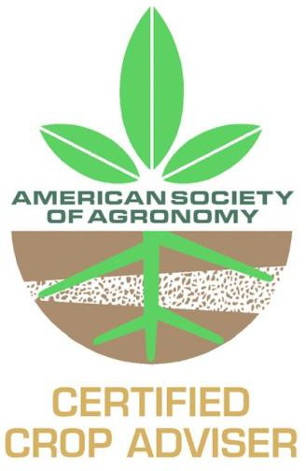

Hotel Options
Best Western Smithfield Inn 145 S Equity Dr.
Smithfield NC 27577

Comfort Inn 170 S Equity Dr.
Smithfield NC 27577

Super 8 Smithfield 735 Outlet Center Dr. Smithfield NC 27577

Sleep Inn & Suites 270 N Equity Dr. Smithfield NC 27577

Fairfield Inn & Suites by the Marriott Smithfield 809 Venture Dr.
Smithfield NC 27577

Baymont Inn & Suites 125 S Equity Dr.
Smithfield NC 27577

Holiday Inn Express Hotel & Suites 190 S Equity Dr.
Smithfield NC 27577
Hampton Inn
695 Outlet Center Dr. Selma, NC 27576

Several restaurants are within walking distance from hotels, including Outback, Texas, Buffalo Wild Wings, Chipotle, San Marcos, Bob Evans, CiCi’s, and Cracker Barrel. The Outlet Mall and is also within walking distance.

Registration & Fees

Early Registration Fee* $100.00
Late Registration Fee** $125.00
*There is no partial registration fee
**Postmarked after November 20th

Preregistration is encouraged. For pay-at- the-door registrants, expect a registration delay and please be prepared to pay the $125 fee by check (made payable to Duplin County Extension Center) or $125 cash (correct change). Check is preferred. Credit card payment is not accepted.

Your registration fee includes class materials, light breakfasts, refreshment breaks, and lunches.

This training will provide 20 total CCA CEUs. Daily CEU offerings are:

Educational  Area | Dec.  10 | Dec.  11 | Dec.  12
SW | 1.5 | 2.5 | 1
PM | 1 | 3 | 1
CM | 3 | 2 | 0
NM | 2.5 | .5 | 2

A complete agenda including topics, speakers, and assigned CEUs is available at http://Johnston.ces.ncsu.edu

Eastern North Carolina Certified Crop Adviser Training Johnston County Extension Center
Smithfield, NC December 11-13, 2018 Registration Form
Name: Company: Address: City:
State: Zip: Email: Phone:
Make checks payable to:
Duplin County Extension Center Early Registration Fee: $100.00 Early Registration Deadline: November 20, 2019 postmark
Late Registration Fee: $125.00
Mail To: Adam Ross
Duplin County Center NC Cooperative Extension PO Box 949
Kenansville, NC 28349
Receipt# (office use only)
Upon receipt of your registration, you will receive an email confirmation. A training fee receipt will be. provided in your Welcome Packet upon check-in

If you have general questions or need additional information, please contact:

Wesley Stallings
Phone: (919) 495-5744
Email: wcstalli@ncsu.edu

For payment or registration questions, contact:

Adam Ross
Phone: (910) 296-2143
Email: adam_ross@ncsu.edu

http://Johnston.ces.ncsu.edu

Accommodations for individuals with disabilities or special needs: Individuals with disabilities or special needs desiring accommodations to participate in these activities should contact Johnston County Extension at (919) 989-5380 at least two weeks prior the event. NC Cooperative Extension takes seriously its obligation to accommodate the known disabilities of its faculty, staff and guests

NC State University and North Carolina A&T State University commit themselves to positive action to secure equal opportunity regardless of race, color, national origin, religion, political beliefs, family and marital status, sex, age, veteran status, sexual identity, genetic information or disability. NC State University,
N.C. A&T State University, U.S. Department of Agriculture, and
local governments cooperating
Eastern North Carolina Certified Crop Adviser Training
Johnston County Center
NC Cooperative Extension Service 2736 NC 210 Highway
Smithfield, NC 27577

December 10-12, 2019

