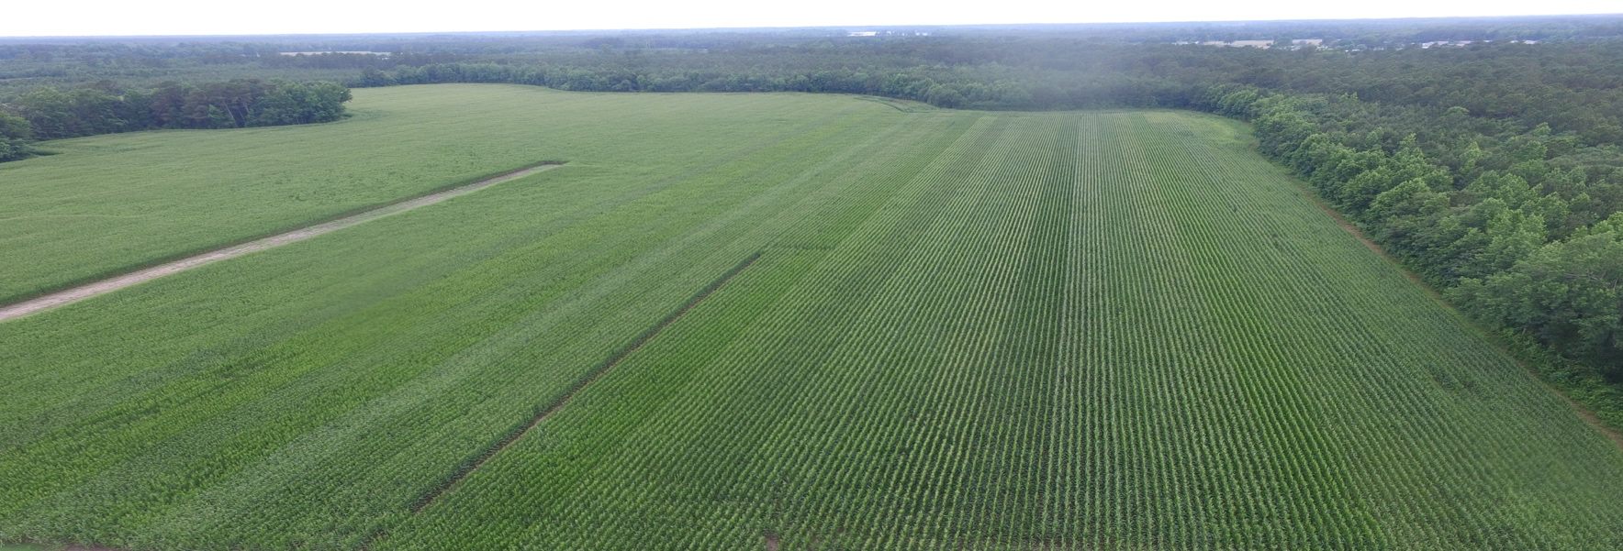

**Certified Crop Advisors Training**  
  
December 10th- December 12th

Johnston County Cooperative Extension

2736 NC Highway 210,

Smithfield, NC

Topics from NCSU Specialist, Extension Agents, and Industry leaders include: variety information, entomology, plant pathology, advance in technology, nutrient & water management, and crop management.

For more information contact your local county extension agent or go to https://onslow.ces.ncsu.edu

Wesley Stallings – 919-495-5744

North Carolina Cooperative Extension Service

*North Carolina State University and North Carolina A&T State University commit themselves to positive action to secure equal opportunity regardless of race, color, creed, national origin, religion, sex, age, veteran status or disability. In addition, the two Universities welcome all persons without regard to sexual orientation. North Carolina State University, North Carolina A&T State University, U.S. Department of Agriculture, and local governments cooperating.*