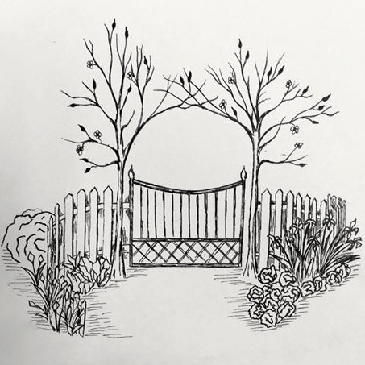

IN THE GARDEN NOW
HELPING GARDENERS PUT KNOWLEDGE TO WORK

September 2018

Growing Onions

Jim Kwasnik, Master Gardener Volunteer

Growing edible onions (Allium capa) in North Carolina is fairly easy to do with proper soil preparation and garden care. Onions need full sun, well-drained soil with a good amount of organic matter (well-rotten compost), and pH 6.5 -6.8. The area planted should be weed free and watered as necessary during dry spells.

There basically two types of onions: (1) branching or green onions and (2) bulb onions. Bulb onions are further divided into the sweet (short-storage) onions or the cooking (long day/longer-storage) onions. Bunching onions do well under most conditions but bulb onions are dependent on day-light hours for bulb formation. If bulb onions do not have the correct light requirements they will produce only greens or very small, if any, bulbs.

Bulb onions are divided into three growing types depending on the amount of daylight needed for bulb formation: (1) short-day, 10-12 hours; (2) intermediate-day, 12-14 hours; and (3) long-day, 14-16 hours. Long-day onions are not recommended for our area. Unfortunately, the onion sets sold in big box stores are usually long-day onions and will not form properly in our area.

It is best to prepare ground in fall as average planting dates in Onslow County for live onion plants is February 10 through March 10. Later planting will produce a smaller bulb given same plant conditions. Onion varieties that grow well in our area that are found as plants includes (short-day) Yellow Granex, Granex 33, TX Early Granex 1015Y and (intermediate-day) Super Star, Candy, and Red Candy Apple. Plant the onions no deeper that 1” as planting deeper will prohibit bulb formation. In our acidic soils, fertilize every 2-3 weeks with a ½ cup of calcium nitrate (15.5-0-0) per 10 foot of row until the bulb starts to form.

When the tops die back, remove the onions from the ground, cut off any roots and allow them to cure in the sun for 2-3 days. Place the greens over the bulb to prevent sunscald. If rainy conditions are present, then move your harvest to a ventilated indoor storage area or garage. Once the tops are dry, cut off the tops and place the bulbs in mesh bags or open boxes for longer storage. Store in a cool area. Storage life is generally 30-60 days for short-day onions and 60-90 day for intermediate day onions. Check your harvest every few weeks and remove any soft onions to prevent others from rotting.

**Map on the next page shows the different growing requirements.

Lisa Rayburn
Extension Agent, Horticulture

Contact Us:

NCCE-Onslow County
4024 Richlands Hwy.
Jacksonville, NC 28540

(910) 455-5873
(910) 455-0977 Fax
http://onslow.ces.ncsu.edu

North Carolina State University and North Carolina A&T State University commit themselves to positive action to secure equal opportunity regardless of race, color, creed, national origin, religion, sex, age, veteran status or disability. In addition, the two Universities welcome all persons without regard to sexual orientation. North Carolina State University, North Carolina A&T State University, U.S. Department of Agriculture, and local governments cooperating.

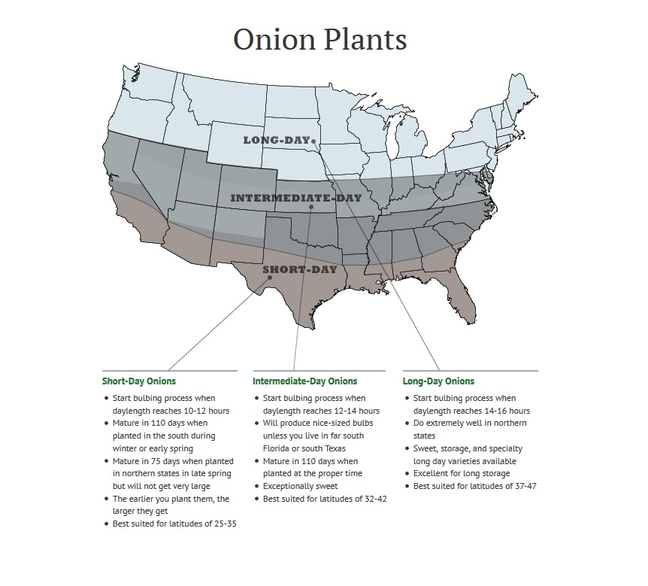
Dixondale Farms. http://www.dixondalefarms.com/category/onion_plants

Tips and Tasks

Peak Season Soil Sample Testing Fees
If you haven’t sampled your soil recently, go ahead now to avoid the peak season sample fee. If you send your sample through the Onslow County extension office, make sure it is received by November 15 to ensure that it reaches NCDA by deadline.

Wait times are significantly shorter if you submit your samples during the off-season. It usually only takes about 7-10 days for the lab to process samples during the non-peak season; during peak season, sample turnaround times can stretch to 8 or 9 weeks.

For more information about these fees, check out the Onslow County Cooperative Extension website, http://onslow.ces.ncsu.edu/2013/07/peak- season-soil-testing-fee/.

Garden
* There is still time to plant! In September, you can plant onions, radishes and second plantings of short season hardy crops like leaf lettuce and spinach. Cabbage, kale, collards, Swiss chard and leaf lettuce can be set out through mid-October. Seeds of radish, spinach, turnip and salad greens can also be sown. Plant garlic cloves and onion sets until November.

* Cool season herbs like dill, parsley and cilantro can be direct sown or set out as transplants and will stay green into winter.

* Extend the growing season of tender summer crops like tomatoes and peppers by covering them through the first couple of frosts. We often have several weeks of nice growing weather after the first fall frost.

* Clean up time! Remove old plants, as well as any foliage that has fallen on the soil and compost them. Do a final weeding, and mulch the bed with compost, straw, grass clippings, or chopped leaves. These mulches can be turned into the soil next spring to help fertilize next year's crops. Collect leaves and debris for composting but don’t compost insect or disease-laden plant material or weeds that have gone to seed. As perennial beds go dormant, cut dry dead foliage back to ground level. Seed heads may be left for winter interest or to feed the birds (sedum, echinaceae, blackeyed susan). Leave ornamental grasses standing for seasonal interest and to provide overwintering habitat for wildlife and beneficial insects.

Lawn
* Warm season grasses do not grow during late fall and don’t require any nitrogen before spring. Fertilizing with nitrogen at this time will encourage weed growth and disease problems like large patch and winterkill. Instead, opt for a September application of a potassium fertilizer on sandy soils. Potassium can improve winter hardiness while improving disease and drought tolerance.

* Raise the height of your lawn mower by 1⁄2 inch in mid-September to encourage your lawn to store energy for winter and protect your grass from winterkill.

* Resist the urge to overseed your permanent lawn with ryegrass. While this provides winter color, competition with ryegrass in the spring can stress your lawn – particularly centipede and St. Augustine.

* If you had large patch diagnosed this spring, apply protective fungicides the beginning of September and again in October for control. Azoxystrobin is an effective fungicide for large patch control. This active ingredient can be found under the trade name Heritage G, as a generic, or in Scott’s Disease EX. Also, make sure that you are not irrigating through the fall.

Trees and shrubs
* Fall is the best time of year to transplant trees, shrubs, and perennials. Keep new plantings watered as they get established.

* Prune shrubs to remove dead, diseased or broken limbs: however, save significant pruning for late winter or early spring. Spring blooming shrubs shouldn’t be pruned until after they flower, or you will lose next spring’s blooms.

* Once all of the leaves have fallen, give your landscape plantings a layer of mulch over top. Three to four inches of mulch is good but excessive mulch can also cause problems so check the thickness of your mulch. Old mulch can be freshened up by raking. Don’t let mulch lie against the trunks of trees and shrubs or it will encourage pest and disease problems.

*Fig bushes damaged by last winter’s cold may set small figs that do not ripen before frost. Consider covering your bushes for protection this winter.
………………………………………………………………………………………………………………………
We want your feedback! If you like our newsletter, or want to see something new, let us know! Give us a call 910.455.5873 or email lisa_rayburn@ncsu.edu. Speaking of new, we have a new volunteer working on our newsletter. If you see Jessie at our next Master Gardeners course, say hi!
…………………………………………………………………………………………………………………….

Classes

Vegetable Gardening 101 Series
Lettuce and Spinach
Sept 15th
10 am Cost: free
Registration: 910.455.5873
Location: Discovery Gardens
We will meet the third Saturday of each month, at 10 am, in the Discovery Garden (besides the Farmers’ Market). Come plant and tend the vegetables in the raised bed gardens with us. Each month, we will discuss what we are planting and why. Then you can help plant! These informal classes will be a great
way to get your hands dirty, ask questions and get ideas that you can apply in your own garden.
…………………………………………………………………………………………………………………

Free Seeds for School and Community Gardens
We were blessed with a large donation of vegetable and flower seeds. If you work with a school or community garden, please contact us to pick up free seeds for use in your garden! Contact lisa_rayburn@ncsu.edu or call 910.455.5873 to set up a time to meet.

…………………………………………………………………………………………………………………

Association Meetings

Onslow County Master Gardener Volunteer Association Meeting
September 13th , 9 am
Contact: Lisa Rayburn, 910.455.5873, lisa_rayburn@ncsu.edu

Onslow County Beekeepers’ Association Meeting
September 11th 7 pm
Contact: Curt Hildt, President 910-545-8582

Onslow County Farmers’ Market Board Meeting
September 26th , 5:15 pm
Contact: Marie Bowman 910.455.5873 mkschwei@ncsu.edu

………………………………………………………………………………………………………………
Our market is seasonal. The Tuesday and Thursday market are now closed for the season. Please join us at our Saturday market for a selection of local produce, meats, wines, jams and jellies, honey, eggs, baked goods, crafts, vegetable transplants and more!

Vendors vary from market to market so make sure you check out all three locations:
Saturdays from 8:30 to 1:30 at 4024 Richlands Highway
Tuesdays from 8:30 to 1:30 at 4024 Richlands Highway
Thursday from 10 to 2 on Camp Lejeune

Szechuan Dry-fried Green Beans
Time: 15-20 min, prep to table
Serves: 4

Those beautiful, tangled green beans in the market belong on your plate! Using an easy Chinese dry frying method called gan bian, this spicy, blistered dish is highly addictive. This is a great excuse to use your wok, but a cast iron skillet works just as well!

1 lb green beans, haricots verts or longbeans
1 tablespoon garlic, chopped
1 tablespoon ginger, chopped
2 scallions (spring onions, green onions), white parts only, finely chopped
1/2 teaspoon chili paste
1 tablespoon soy sauce
1/2 teaspoon sugar
1/4 teaspoon salt, or to taste
Pepper and/or red pepper flakes to taste (optional)
2 tablespoons peanut or vegetable oil, or as needed

Wash the green beans, drain and pat dry, and trim ends.
Cut beans on the diagonal, approximately 2 inches long.
Chop garlic, ginger and scallions.

Heat 1 tablespoon oil over medium heat.
Add the green beans and stir-fry until they start to shrivel or "pucker" and brown (6 to 7 minutes).
Remove the green beans from the pan and drain in a colander.

Heat 1 tablespoon oil in the pan on high heat.
Add the garlic, ginger and scallions. Stir-fry for a few seconds, then add the chili paste and stir-fry for a few more seconds until aromatic.
Add the green beans and the dark soy sauce, sugar, salt, and pepper if using.

Stir everything together, and taste and adjust the seasoning if desired. Serve hot.

* discovered on Epicurious

CONTACT US
If you have questions about lawn, landscape or garden problems, contact your local Cooperative Extension office. In Onslow County call 910.455.5873, Mon. – Fri., 8 am – 5 pm, or visit us online anytime at http://onslow.ces.ncsu.edu. While you are there, you can post your questions to be answered by email using the “Ask an Expert’ widget in the upper left-hand corner.

