SUMMER DAY CAMP ENROLLMENT FORM 2018
Wetland Wonders: Environmental Science Camp
Location: Onslow County Environmental Education Center
Sponsored by Onslow County Museum & NC Cooperative Extension 4H

Camper Information
Name: ___________________________________________ Home Phone: ______________
Address: __________________________________________________________________
City/State/Zip: __________________________________________________________________
Date of Birth: ________________ Age: _____________
T-Shirt (Youth): S M L XL
(Adult): S M L XL

Health Information:
Please indicate in the space below ANY allegories or health conditions for which your child is currently being treated or from which they chronically suffer i.e., diabetes, heart condition, asthma, or other respiratory problems, seizures, ear infections, nosebleeds, allergies, ADD/ADHA, or any inability that may limit the child from fully participating in program activities.
__________________________________________________________________________________________________

***Release: Photo release: I agree to allow photographs, video, and/or audio to be taken during Wetland Wonders which may be used for public information, marketing, exhibition, and educational purpose. _______________ (please initial)

***Field Trip: In addition to activities at the Environmental Education Center, Wetland Wonders will also travel to River Park North located in Greenville, NC.

Parent/Guardian/Family Information
Mother’s Name: _________________________________________________________
Work Phone: _______________________ Mobile: _______________________
E-Mail: _______________________________________________________________

Father’s Name: __________________________________________________________
Work Phone: _______________________ Mobile: ________________________
E-Mail: _______________________________________________________________

Other Siblings in the Wetland Wonders Camp Program: ___________________________________________

Authorization for Release:
Please list the name and phone number of two (2) people who can be notified if your child needs to be picked up from the program in the event of an emergency and/or some other reason and a parent/guardian cannot be located or contacted.

- Name: _____________________________________ Relationship: ________________________
Phone #: _____________________________________

- Name: _____________________________________ Relationship: ________________________
Phone #: _____________________________________
Medical Emergency Information:
Hospital Preference: _________________________________________________________________________
Child’s Physician: __________________________________________________________________________
Child’s Dentist: __________________________________________________________________________
Name of Insurance: __________________________________________________________________________

In case of medical emergency, I understand every effort will be made to contact one or both parents/guardians and/or those persons listed under the “Authorization for Release” section of the enrollment form. In the event none of the above can be reached, I hereby give permission to the Wetland Wonders Camp Director to secure proper medical treatment by calling the appropriate persons and/or facility who may hospitalize and/or order injection, anesthesia, or surgery for my child.

Signature: ___________________________________________________________ Date: ____________________

Field Trip Authorization:

My child, ____________________________, has my permission to participate in the scheduled field trip departing NC Cooperative Extension traveling to River Park North in Greenville. I hereby release the Onslow County Museum and NC Cooperative Extension (its agents, officials, employees, staff, and board members) of any liability and understand that my child will NOT be able to attend the field trip without this permission form.

Signature: ________________________________________________ Date: __________________________

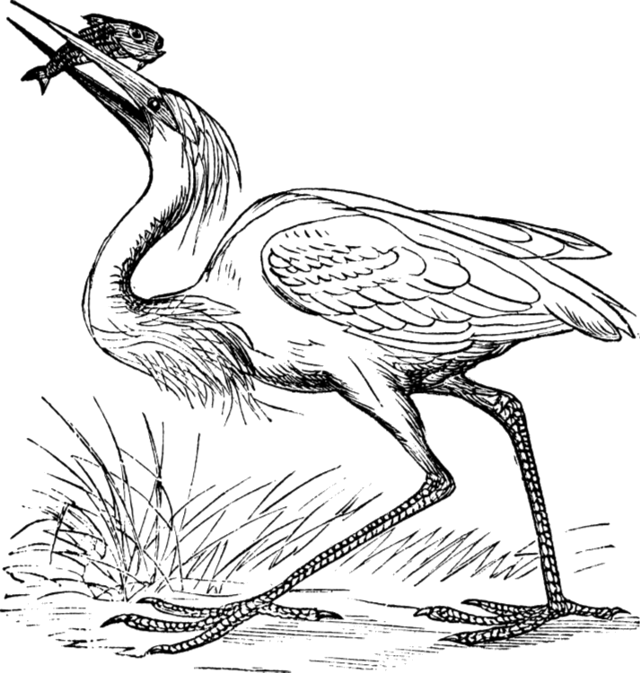
Make Checks out to:
Onslow County

Send Payment & Registration Forms to:
NC Cooperative Extension
Attn: 4-H
4024 Richlands Hwy
Jacksonville, NC 28540

