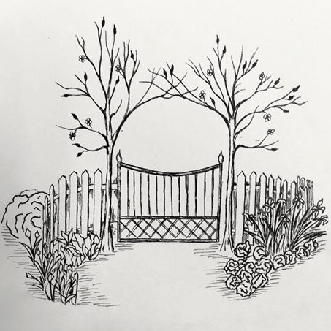

IN THE GARDEN NOW
HELPING GARDENERS PUT KNOWLEDGE TO WORK

February 2018

Impact of Winter Weather on Plants

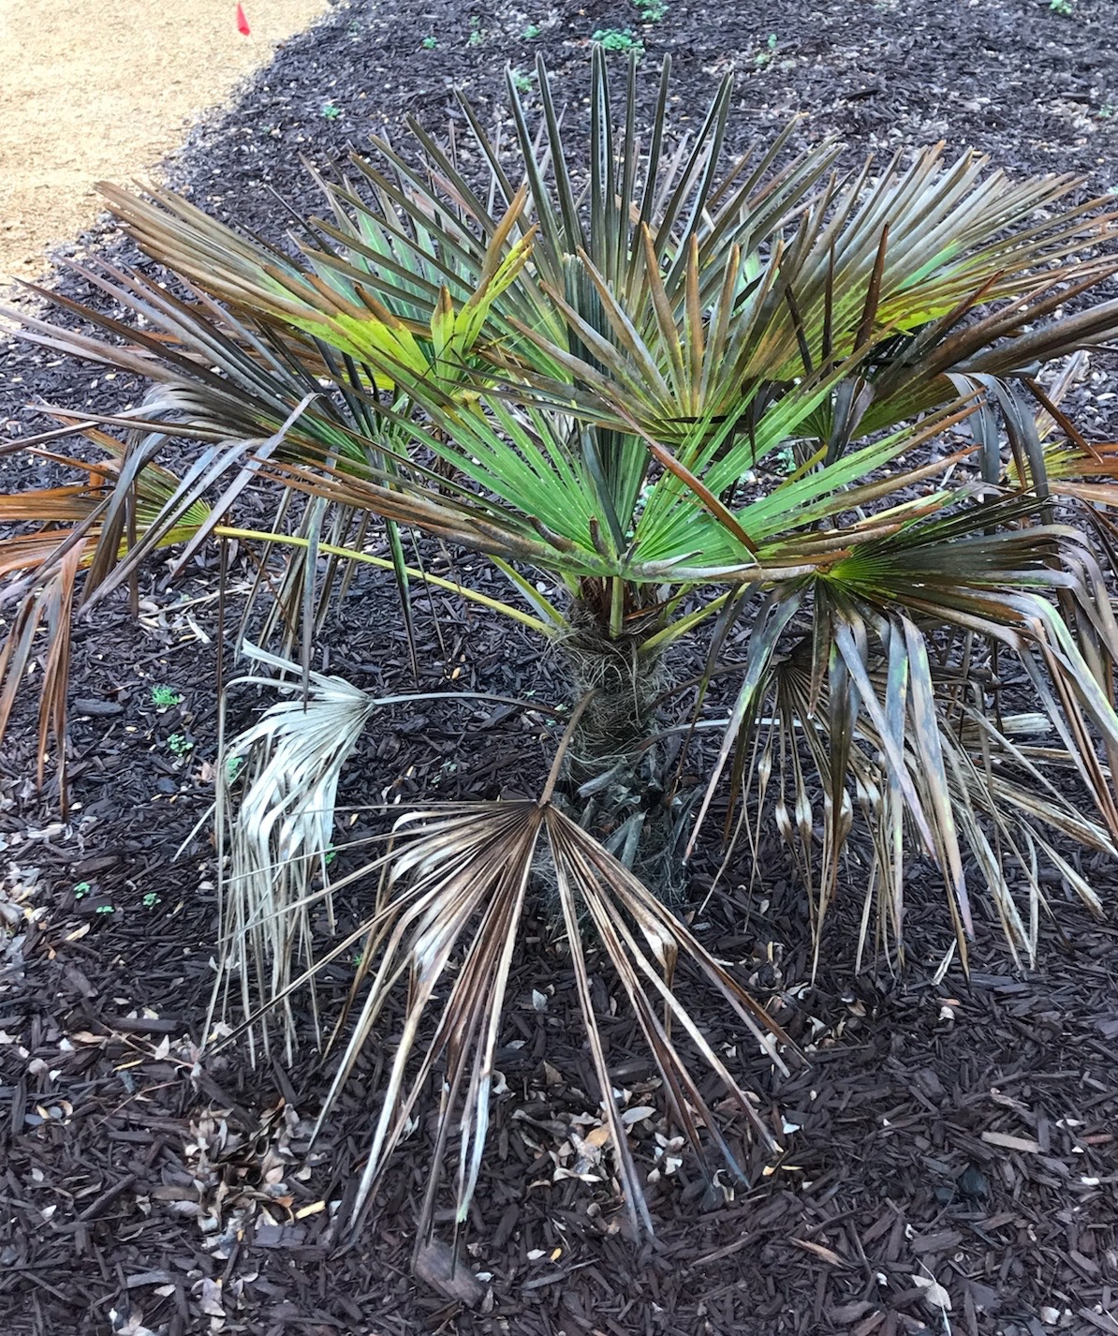

January brought unusually cold and snowy weather to Onslow County. These low temperatures can cause problems in the landscape including cold damage to plants and the possibility of salt burn from de-icing products.

There are many cold damage symptoms that can show up on plants but brown foliage or dead shoot tips are the most common. Resist the urge to go out and prune cold damaged plants. We have more cold weather yet to come and the browned leaves and damaged stem tissues will actually protect the rest of the plant from additional damage. Once new growth resumes in the spring, you will be able to see what tissue is alive and what is dead. Then you can carefully remove dead and damaged parts of the plant.

Cold damage can be hard to predict and plants respond differently based on the species and other factors. Young, newly established plants and plants in exposed locations are more likely to suffer cold damage compared to older, established plants and plants in protected locations. Plants that are otherwise under stress or plants growing at the northern end of their range are more susceptible to damage as well.

January brought unusually cold and snowy weather to Onslow County. These low temperatures can cause problems in the landscape including cold damage to plants and the possibility of salt burn from de-icing products.

There are many cold damage symptoms that can show up on plants but brown foliage or dead shoot tips are the most common. Resist the urge to go out and prune cold damaged plants. We have more cold weather yet to come and the browned leaves and damaged stem tissues will actually protect the rest of the plant from additional damage. Once new growth resumes in the spring, you will be able to see what tissue is alive and what is dead. Then you can carefully remove dead and damaged parts of the plant.

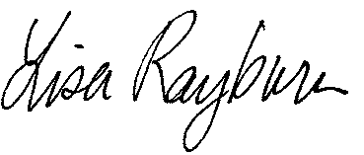

Lisa Rayburn
Extension Agent, Horticulture

Contact Us:

NCCE-Onslow County
4024 Richlands Hwy.
Jacksonville, NC 28540

(910) 455-5873
(910) 455-0977 Fax
http://onslow.ces.ncsu.edu

North Carolina State University and North Carolina A&T State University commit themselves to positive action to secure equal opportunity regardless of race, color, creed, national origin, religion, sex, age, veteran status or disability. In addition, the two Universities welcome all persons without regard to sexual orientation. North Carolina State University, North Carolina A&T State University, U.S. Department of Agriculture, and local governments cooperating.

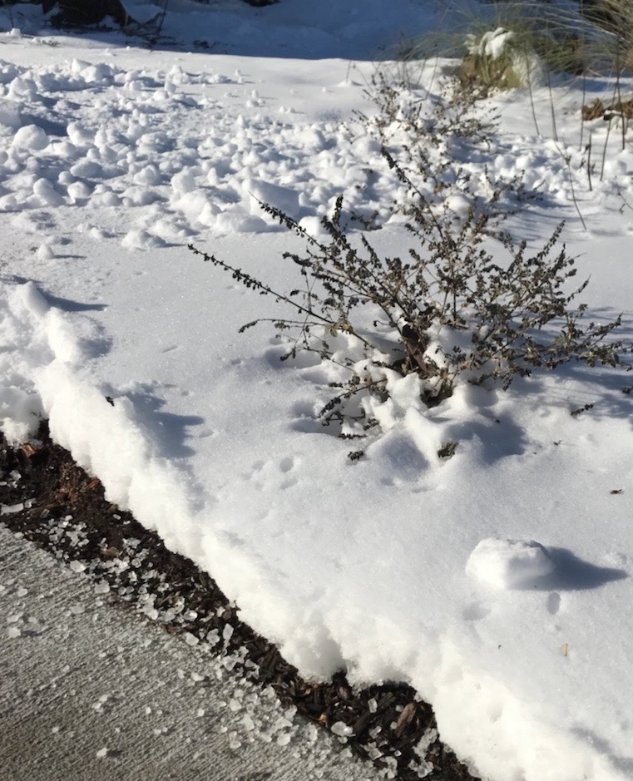
Cold damage can be hard to predict and plants respond differently based on the species and other factors. Young, newly established plants and plants in exposed locations are more likely to suffer cold damage compared to older, established plants and plants in protected locations. Plants that are otherwise under stress or plants growing at the northern end of their range are more susceptible to damage as well.

De-icing products also pose a threat to landscape plants. De-icing products are salts and they can damage plant roots and foliage when they are splashed onto leaves or dissolve in melting snow and run into planting beds. Salt damage can burn evergreen leaves, dry out bud scales and result in damage to the upcoming season’s leaves and flowers. Salts in the soil can displace other minerals resulting in nutrient deficiencies and interfere with water uptake by the roots. The chloride ions from rock salt can be transported within the plant causing leaf burn and die back. Some of these problems will not be obvious until later in the growing season or periods of drought stress.
De-icing chemicals on sidewalk

The closer that plants grow to treated surfaces such as sidewalks or driveways, the more at risk they are of damage. To reduce damage to plants, avoid using de-icing chemicals that contain sodium chloride (table salt, NaCl). Alternative products that do not contain sodium include potassium chloride (KCl), calcium magnesium acetate (CMA) or calcium chloride (CaCl₂) as active ingredients. These products are more expensive but are much less likely to damage plants when properly used. Coarse sand and sawdust are simple, natural alternatives to de-icing chemicals. While they do not melt snow and ice, sand and sawdust will help provide traction on slick surfaces.

If you have evergreen plants that have been exposed to sodium chloride spray, rinse the leaves with plain water as soon as possible after temperatures are above freezing. If salt washes off treated surfaces and soaks into the soil around sensitive trees and shrubs, leach the soil by slowly saturating the area with plain water – use a soaker hose or drip irrigation to run for 2-3 hours. We had some heavy rains after our snow event that will help naturally leach some of the salt away.

Luckily for us, salts applied in early winter tend to result in less damage than salts applied in late winter since there is a better chance that the salt is leached away before active root growth in spring.

……………………………………………………………………………………………………………………………………………………………

Tips and Tasks
Prune back ornamental grasses and ground covers in early February before new growth starts. Add mulch to beds if needed.

Scale can be a problem on hollies and other shrubbery both outside and on indoors houseplants. Scale are small, hardbodied insects that often look like bumps on the bark or leaves of the plant. Scale on landscape plants can be treated with horticultural oils. Follow the label directions and use the spray rate recommended for the time of year. Acephate (Orthene), carbaryl or insecticidal soap can also be used. Insecticidal soap is a good choice for scale on houseplants. A second treatment after two weeks is generally needed to control newly emerged scale insects. With any product, read and follow all label directions and remember that thorough coverage is critical for control.

Plants naturally change color in the winter and even evergreens like azaleas, gardenias and camellias can experience yellowing. Older leaves naturally yellow and drop off. If azaleas are discolored and the leaves show stippling (tiny discolored spots), spider mites could be the culprit. Spider mites can be controlled with horticultural oil or insecticidal soap.

Dormant pruning of fruit trees and grapevines should be done in February as should heavy pruning and rejuvenation pruning of most ornamental shrubs. Remember to wait and prune spring flowering shrubs such as azaleas and forsythia after they bloom.

If you are using a preemergent herbicide to control summer annual weeds (including crabgrass) in your lawn, aim to apply it around Valentine’s Day. If these chemicals are applied too late, you will not get adequate weed control. Read and follow all label directions. Avoid weed-and-feed formulations and wait until mid-May to June to fertilize warm season lawns.

If you are battling Florida betony, remember to apply herbicides in February before the plant starts developing its distinctive tubers.

Remove leaves and debris from lawns. Do not burn St. Augustine, centipede, or zoysiagrass lawns. Irrigation is usually not necessary during the winter months. The optimum time to seed or lay sod for a warm season lawn is in the spring from about April until July 1.

Plan your spring vegetable garden. Cool season crops need to be planted early enough to harvest before the heat of summer hits. Beets, broccoli, cabbage, carrots, cauliflower, kale, kohlrabi, lettuce, mustard greens, onion, garden peas, potatoes, radishes, spinach and turnips can all be planted in February for spring harvest. Start seeds for warm season crops like tomatoes and peppers under lights 6-8 weeks before you intend to transplant them outside.
……………………………………………………………………………………………………………………………………………………………

Association Meetings

Onslow County Master Gardener Volunteer Association Meeting
February 8, 9 am
Contact: Lisa Rayburn, 910.455.5873, http://lisa_rayburn@ncsu.edu

Onslow County Beekeepers’ Association Meeting
February 13, 7 pm
Contact: David Peed, 910.330.7584 or myscubashop@yahoo.com

…………………………………………………………………………………………………………………

Classes

Grow Your Own: An Introduction to Vegetable Gardening
February 10, 8:30-3:30 pm
Cost: $15
Registration required by Feb. 5: 910.455.5873
Location: Onslow County Extension Office
Learn all the basics that you need to start growing your own vegetables. We’ll cover garden planning, variety selection, soil and plant nutrition, starting seeds indoors, and building a raised bed. We will have hands on planting demonstrations. Lunch and refreshments will be provided.

Garden Basics – Growing Peas and Potatoes
February 16, 10 am
Cost: free
Registration: 910.324.5212
Location: Onslow Feed and Grain, Richlands
We’ll discuss the basics to get you started in the garden this spring. Then we’ll cover planting some of our earliest crops – garden peas and potatoes.

Propagation for Profit
March 1, 8:30 to 3:45 pm
Cost: free
For more information contact: Wesley Stallings, Wesley_stallings@ncsu.edu, 252.448.9621 or Lisa Rayburn, lisa_rayburn@ncsu.edu, 910.455.5873
Registration required online by February 23: goo.gl/ESdLgW
Location: Onslow County Extension Office
Are you a grower looking to maximize the quality of your vegetables through your propagation practices and management? If so, join us for this day-long workshop. We will cover the Propagation Environment, Seed Physiology, Media and Nutrient Needs, and Saving Your Own Seed. Registration is free but must be completed online by February 23.

Fruit Pruning Workshop
March 10, 8:30 am – 3:00 pm
Location: Xanadu Farm, Holly Ridge
Cost: $5
Registration required by March 2 910.455.5873
Learn how to properly train and prune a variety of fruits including apples, pears, pecans, grapes and blueberries. We will have hands on pruning opportunities. Lunch and refreshments will be provided.

Common Vegetable Garden Problems
March 16, 10 am
Cost: free
Registration: 910.324.5212
Location: Onslow Feed and Grain, Richlands
We’ll discuss common problems in the vegetable garden and how to manage them.

Vegetable Gardening 101 Series
March 17, 10 am
Cost: free
Registration: 910.455.5873
Location: Discovery Gardens
We will meet the third Saturday of each month, at 10 am, in the Discovery Garden (beside the Farmers’ Market). Come plant and tend the vegetables in the raised bed gardens with us. Each month, we will discuss what we are planting and why. Then you can help plant! These informal classes will be a great way to get your hands dirty, ask questions and get ideas that you can apply in your own garden.

Beekeeping Short Course
March 10, 17, 24, 31, 8 am to noon
Cost: $65
Registration or more information: Eric Talley, erictalley@ec.rr.com or 910.389.7709
Location: Onslow County Extension Office
16 hours of basic beekeeping knowledge to get you started and then a mentor to keep you learning. There will be a field day in July for Practical Application and Certification. Registration required.

Back to Basics Gardening Series
Wednesdays, 6-8 pm
Cost: free
Registration: 910.455.5873
Location: Onslow County Extension Office

March 7 – Understanding Your Soil and Plant Fertility
March 14 – Planting Trees and Shrubs & Site Selection
March 21 – Common Landscape Problems
March 28 – Vegetable Gardening 101
April 4 – Common Vegetable Garden Problems
April 11 – Getting Started with Backyard Chickens
April 18 – Growing Fruit in Onslow County
April 25 – Composting

CONTACT US
If you have questions about lawn, landscape or garden problems, contact your local Cooperative Extension office. In Onslow County call 910.455.5873, Mon. – Fri., 8 am – 5 pm, or visit us online anytime at http://onslow.ces.ncsu.edu. While you are there, you can post your questions to be answered by email using the “Ask an Expert’ widget in the upper left-hand corner.

